Compiler Construction Lab
Gull e Zahra (54154)

Lab 4
Task 1
#include <iostream>
using namespace std;

struct Symbol
{
string name;
string type;
string value;
int size;
};

int getSize(string type)
{
if(type == "int") return 4;
if(type == "float") return 4;
if(type == "char") return 1;
return 0;
}

int main()
{
Symbol table[10];
int n;

cout << "How many identifiers? ";
cin >> n;

for(int i = 0; i < n; i++)
{
cout << "\nEnter data type: ";
cin >> table[i].type;

cout << "Enter name: ";
cin >> table[i].name;

cout << "Enter value: ";
cin >> table[i].value;

table[i].size = getSize(table[i].type);
}

cout << "\n--- Symbol Table ---\n";
cout << "Name\tType\tValue\tSize(bytes)\n";

for(int i = 0; i < n; i++)
{
cout << table[i].name << "\t"
<< table[i].type << "\t"
<< table[i].value << "\t"
<< table[i].size << endl;
}

return 0;
}

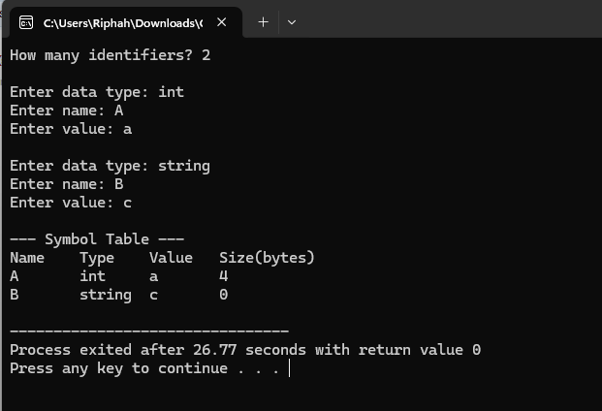

Task 2
#include <iostream>
using namespace std;

struct Symbol
{
string name;
string type;
string value;
};

int main()
{
Symbol table[10];
int n;
bool found = false;

cout << "How many identifiers? ";
cin >> n;

for(int i = 0; i < n; i++)
{
cout << "\nEnter data type: ";
cin >> table[i].type;

cout << "Enter name: ";
cin >> table[i].name;

cout << "Enter value: ";
cin >> table[i].value;
}

string searchName;
cout << "\nEnter identifier to search: ";
cin >> searchName;

for(int i = 0; i < n; i++)
{
if(table[i].name == searchName)
{
cout << "\nIdentifier Found:\n";
cout << "Name: " << table[i].name << endl;
cout << "Type: " << table[i].type << endl;
cout << "Value: " << table[i].value << endl;
found = true;
break;
}
}

if(!found)
cout << "\nIdentifier not found.\n";

return 0;
}
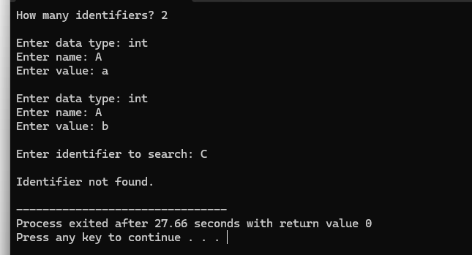

Task 3
#include <iostream>
using namespace std;

struct Symbol
{
string name;
string type;
string value;
};

int main()
{
Symbol table[10];
int n, count = 0;

cout << "How many identifiers? ";
cin >> n;

for(int i = 0; i < n; i++)
{
string name, type, value;
bool duplicate = false;

cout << "\nEnter data type: ";
cin >> type;

cout << "Enter name: ";
cin >> name;

cout << "Enter value: ";
cin >> value;

for(int j = 0; j < count; j++)
{
if(table[j].name == name)
{
cout << "Error: Duplicate identifier!\n";
duplicate = true;
break;
}
}

if(!duplicate)
{
table[count].name = name;
table[count].type = type;
table[count].value = value;
count++;
}
}

cout << "\n--- Final Symbol Table ---\n";
cout << "Name\tType\tValue\n";

for(int i = 0; i < count; i++)
{
cout << table[i].name << "\t"
<< table[i].type << "\t"
<< table[i].value << endl;
}

return 0;
}